**Validation**

Please follow the below examples to validate that you have successfully installed the TurnTo cartridge.

**Create a TurnTo account**

Create a TurnTo account on www.turnto.com/register if you don't already have one.

Make sure your TurnTo Customer Success Manager has added your site to the turnto.com system.

**Business Manager:**

Go to **Merchant Tools > Site Preferences > Custom Preference**. Setup site settings according to “TurnTo SpeedFlex Implementation Guide”.

Go to **Administration > Operations >Jobs**.

Run the **TurnToExportCatalog** Job and wait for the job to finish. Check that the data was imported to the TurnTo site. The TurnTo dashboard should contain information about the imported data. Status of data - New. Wait until the status of imported data is Complete.

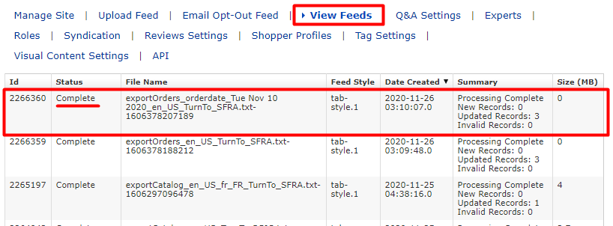

Go to a store, select any product and go to the PDP page.

On the PDP page, you can see widgets with customer reviews about the product as shown below.

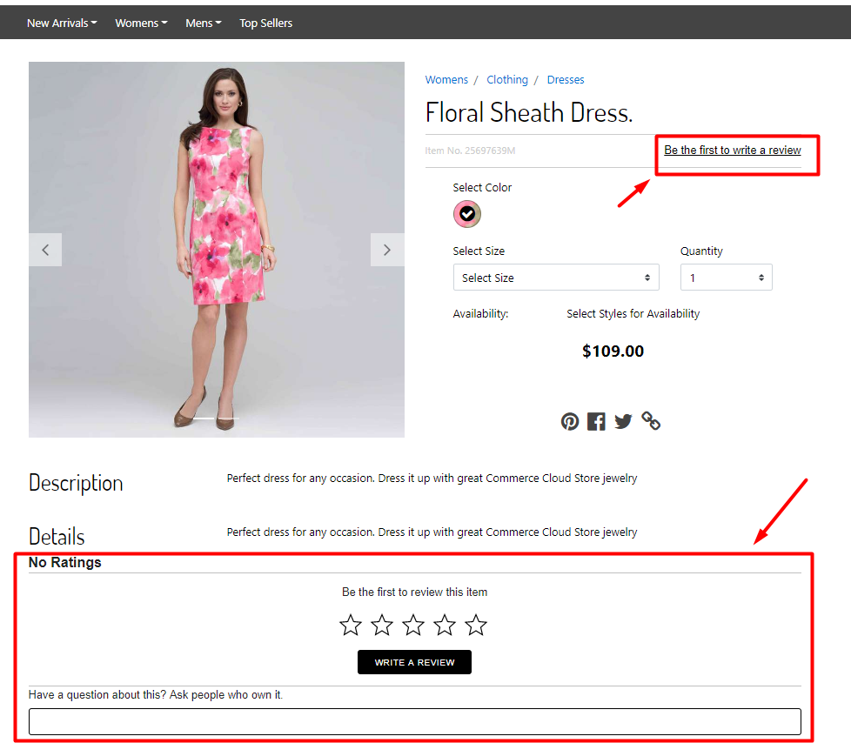

Log in to the store and click on the button “write a review” on the PDP page. Fill out the feedback form and click on the button SUBMIT.

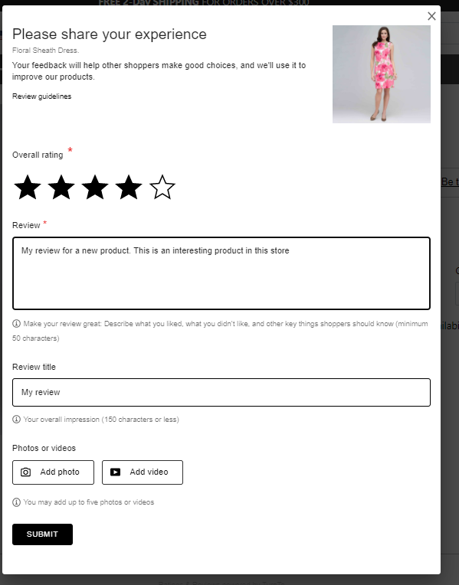

Go to the Turn To dashboard. Your review should appear in your Inbox on the Moderate Reviews page as shown below.

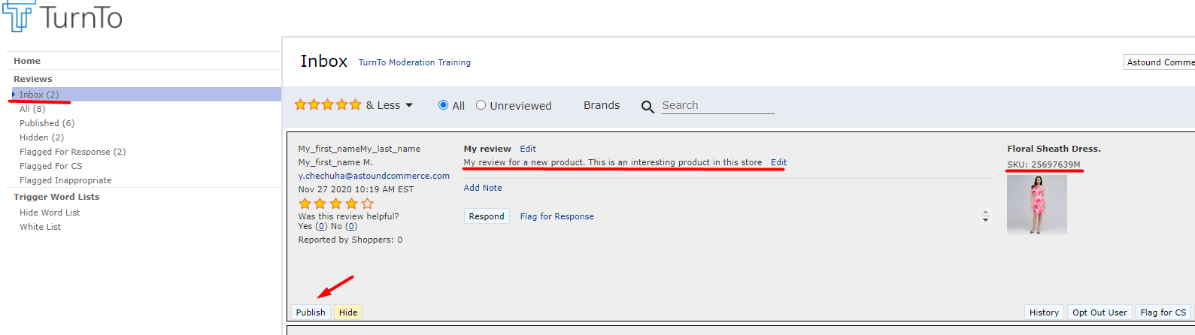

Сlick on the button SUBMIT to make the review appear on the storefront.

The review can now be seen on the PDP page of the product in the storefront.

